Cheatsheet: Operations with Data Types

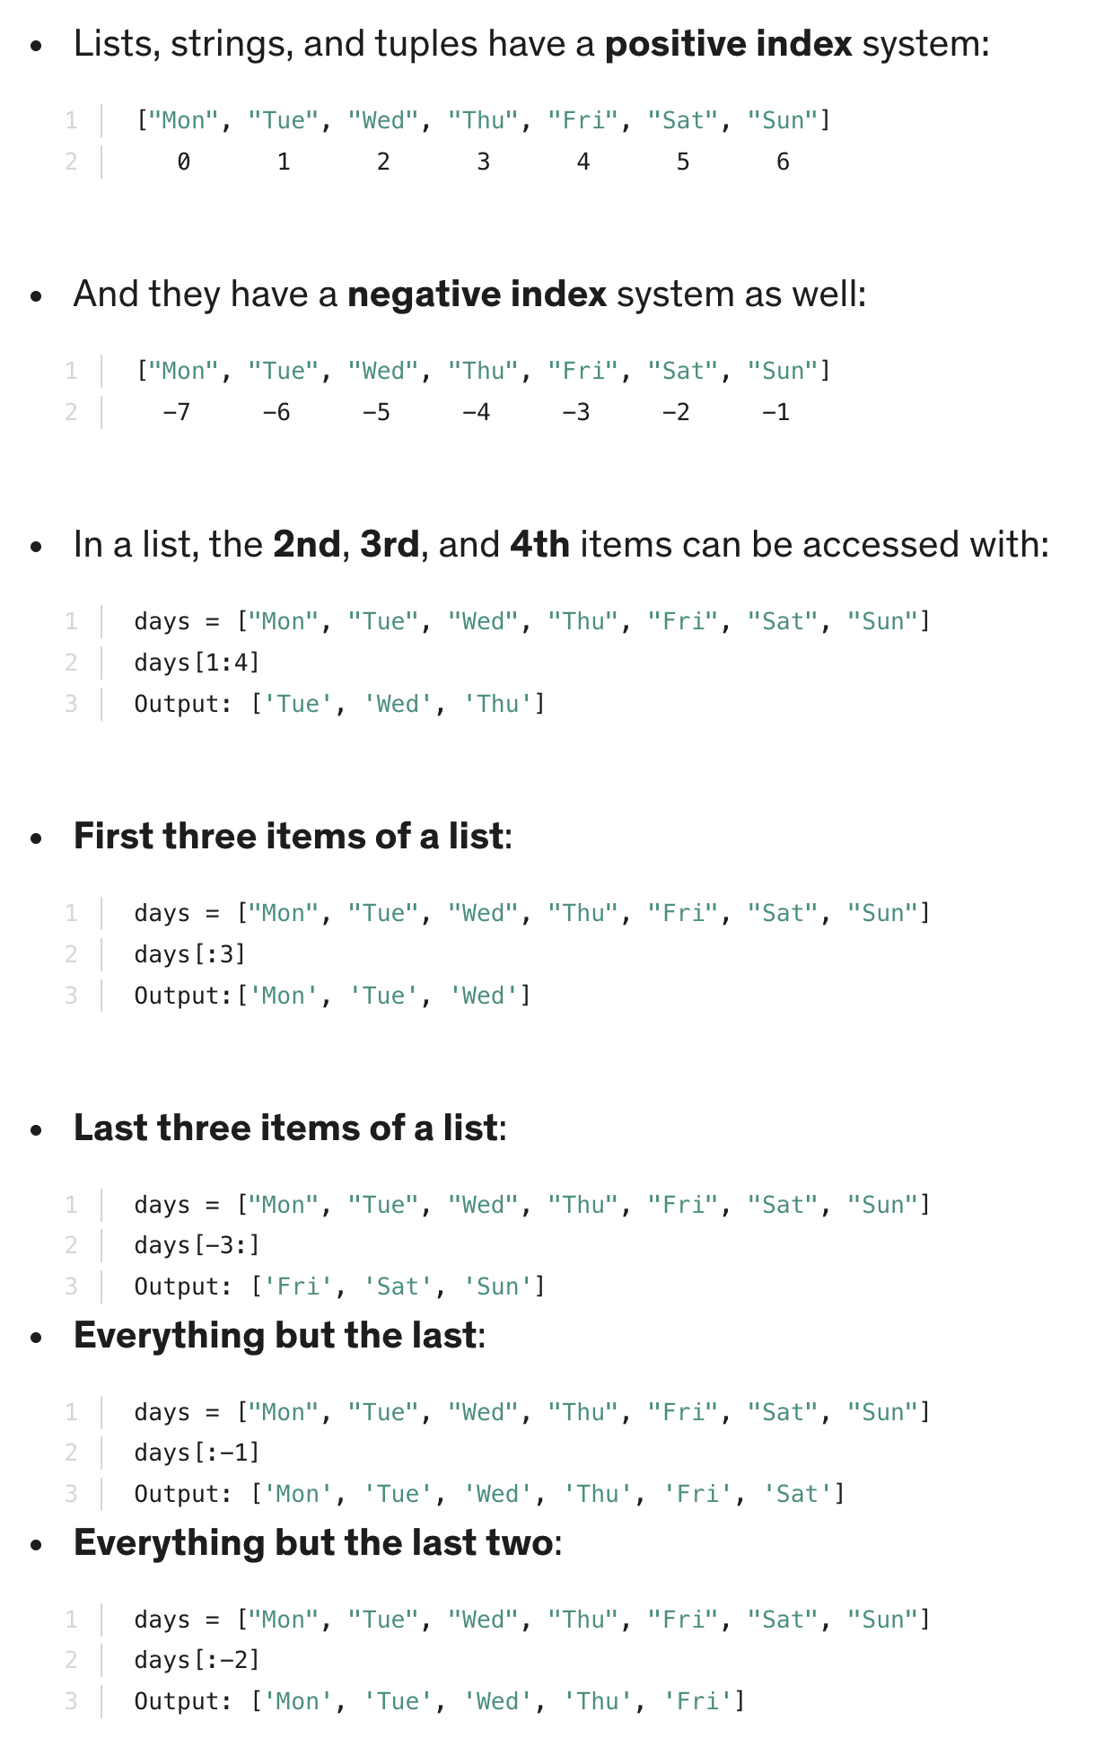
In this section, you learned that:

